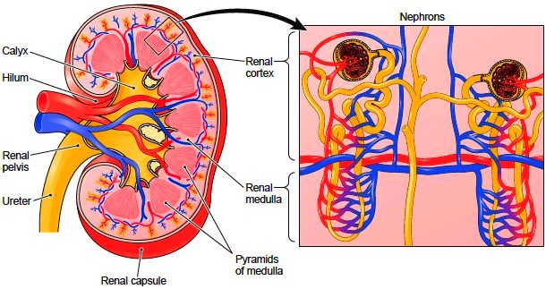

Figure: Longitudinal section through the kidney showing its internal structure (left) and an enlarged diagram of nephrons (right).

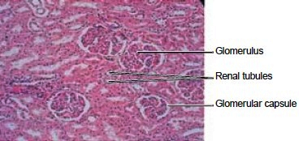

Figure: Microscopic view of the kidney

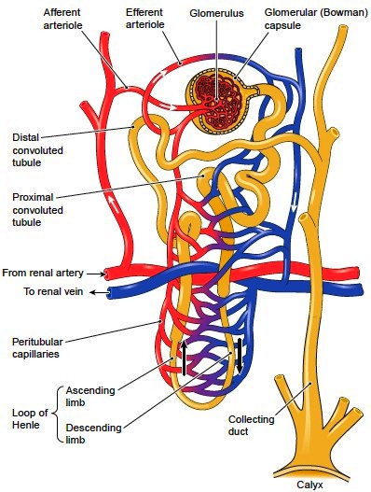

Nephron

